**Netaji Subhash Engineering College**Department of Computer Science & Engineering  
B. Tech CSE 2nd Year 3rd Semester  
2022-2023

__________________________________________________________________________________

**Name of the Course: IT Workshop (Python)**

**Course Code: PCC-CS393**

**Name of the Student: Mayukh Ganguly**

**Class Roll No.: 94**

**University Roll No.: 10900121100**

**Date of Experiment: 13/01/2022**

**Date of Submission:**

|  |  |  |  |  |  |  |  |  |  |  |
| --- | --- | --- | --- | --- | --- | --- | --- | --- | --- | --- |
| **Netaji Subhash Engineering College** | | | | | | | | | | |
| **Department of Computer Science & Engineering** | | | | | | | | | | |
| **INDEX** | | | | | | | | | | |
| **Course Name: IT Workshop (Python)     Student Name: Mayukh Ganguly**  **Course Code: PCC-CS-393                              University Roll No. :10900121100** | | | | | | | | | | |
| **Sl. No.** | **Exp. No.** | **Problem Statement** | **D.O.E** | **D.O.S** | **Marks** | | | **Signature of the Faculty with Date** | | **Remarks     ( if any)** |
| **5** | **15** | **20** |  |  | | |
| 1 | 1 | Write a program to read a number from the user. If the number is positive or zero, print it, otherwise  raise an exception. | **13.01.22** |  |  |  |  |  |  | | |
| 2 | 2 | Write a program to read two numbers from the user and perform basic mathematical operations(addition, multiplication, subtraction, division) by handling all possible exceptions. | **13.01.22** |  |  |  |  |  |  | | |
| 3 | 3 | Write a program to read a number from the user and print its square. Generate KeyboardIntrrupt  exception if Ctrl + C is pressed instead of a number. | **13.01.22** |  |  |  |  |  |  | | |
| 4 | 4 | Write a program to accept a file name from the user and count the number of words present in the file. | **13.01.22** |  |  |  |  |  |  | | |
| 5 | 5 | Write a program to print each line of a file in reverse order. | **13.01.22** |  |  |  |  |  |  | | |
| 6 | 6 | Write a program to reverse the content of a file and store it in another file. | **13.01.22** |  |  |  |  |  |  | | |
| **Average Marks** | | | | |  |  |  |  |  | | |

Problem statement:

Write a program to read a number from the user. If the number is positive or zero, print it, otherwise raise an exception.

Python Code:

try:

num = int(input("Enter a number: "))

if num < 0:

raise ValueError("The number should be positive or zero")

else:

print(num)

except ValueError as e:

print(e)

Sample Output:

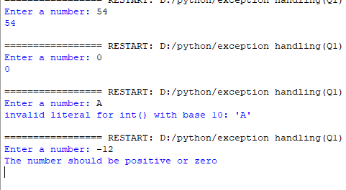

Problem statement:

Write a program to read two numbers from the user and perform basic mathematical operations (addition, multiplication, subtraction, division) by handling all possible exceptions.

Python Code:

while True:

try:

num1 = float(input("Enter the first number: "))

num2 = float(input("Enter the second number: "))

add = num1 + num2

mul = num1 * num2

sub = num1 - num2

div = num1 / num2

print("Addition: ", add)

print("Multiplication: ", mul)

print("Subtraction: ", sub)

print("Division: ", div)

break

except ValueError:

print("Please enter a valid number.")

except ZeroDivisionError:

print("Cannot divide by zero. Please enter a non-zero number.")

Sample Output: 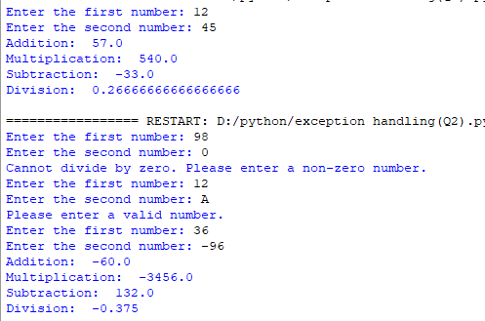

Problem statement:

Write a program to read a number from the user and print its square. Generate KeyboardIntrrupt exception if Ctrl + C is pressed instead of a number.

Python Code:

try:

num = float(input("Enter a number: "))

square = num**2

print("Square: ", square)

except KeyboardInterrupt:

print("Keyboard Interrupt exception caught.")

except ValueError:

print("Please enter a valid number.")

Sample Output:

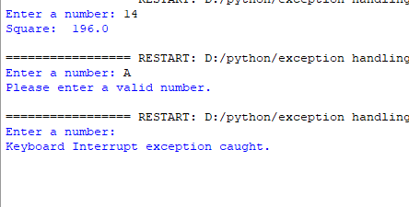

Problem statement:

Write a program to accept a file name from the user and count the number of words present in the file.

Python Code:

try:

filename = input("Enter the file name: ")

with open(filename, "r") as file:

data = file.read()

words = data.split()

word_count = len(words)

print("Number of words in the file: ", word_count)

except FileNotFoundError:

print("File not found. Please enter a valid file name.")

Sample Output:

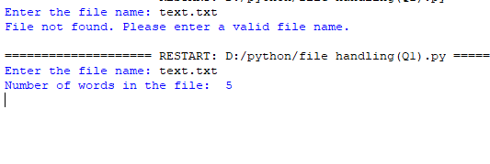

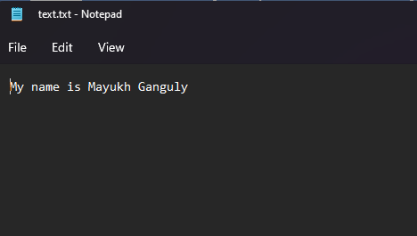

Problem statement:

Write a program to print each line of a file in reverse order.

Python Code:

try:

filename = input("Enter the file name: ")

with open(filename, "r") as file:

lines = file.readlines()

for line in lines[::]:

print(line[::-1])

except FileNotFoundError:

print("File not found. Please enter a valid file name.")

Sample Output:

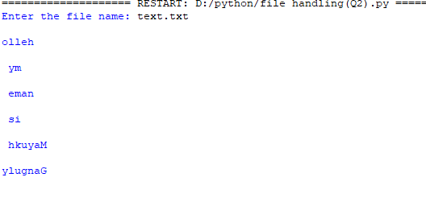

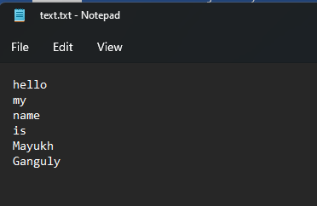

Problem statement:

Write a program to reverse the content of a file and store it in another file.

Python Code:

try:

original_file = input("Enter the name of the original file: ")

reversed_file = input("Enter the name of the reversed file: ")

with open(original_file, "r") as original, open(reversed_file, "w") as reversed:

original_data = original.read()

reversed_data = original_data[::-1]

reversed.write(reversed_data)

print("Data reversed and stored in", reversed_file)

except FileNotFoundError:

print("File not found. Please enter a valid file name.")

Sample Output:

